**C868 – Software Capstone Project Summary**

**Task 2 – Section C**

|  |  |
| --- | --- |
| **Capstone Proposal Project Name:** | http://www.idevnews.com/views/images/uploads/general/wgu_logo.png  CCC SAYOP Registrar – Mobile Application |
| **Student Name:** | Greg Westmoreland |

**Table of Contents**

Table of Contents 2

Task 2 Part C – C868 Software Development Capstone 4

Application Design and Testing 4

Design Document 4

Class Design 4

UI Design 6

Unit Test Plan 6

Introduction 6

Purpose 6

Overview 6

Test Plan 7

Items 7

Features 7

Deliverables 7

Tasks 7

Needs 7

Pass/Fail Criteria 7

Specifications 7

Procedures 8

Results 8

C4. Source Code 8

C5. Link to Live Version 9

User Guide 10

Introduction 10

Installation and Using the Application 10

*Login and Signup (An example*) 10

*Classes* 11

*Create a New Class* 11

*Reports* 12

Task 2 Part C – C868 Software Development Capstone

# Application Design and Testing

# Design Document

## Class Design

There are four database tables that are part of the CCC SAYOP Registrar Mobile Application Version 2. The application uses the Room Persistent Library to make all of the database queries with SQLite that will be installed on the end user’s device. The Entity Relationship Design (ERD) has been provided to show the relationship between the four database tables:

* users_table (1:1) with relationship with Users Data Access Object
* terms_table (1:1) with relationship with Terms Data Access Object
* courses_table (1:1) with relationship with Courses Data Access Object
* assessments_table (1:1) with relationship with Assessments Data Access Object
* terms_table (1:M) with relationship with the courses_table
* courses_table (1:M) with relationship with the assessments_table

There are twelve main classes that are part of the CCC SAYOP Registrar Mobile Application Version 2. These classes consist of:

* Main_Activity_Log_In_Page
* Main_Activity_Home_Page
* Reports_Page
* List_Terms
* Edit_Existing_Term
* Add_New_Term
* List_Courses
* Edit_Existing_Course
* Add_New_Course
* List Assessments
* Edit_Existing_Assessment
* Add_New_Assessment

The Main_Activity_Log_In_Page includes a log in screen for authentication using a username and password to access the application. Once logged in, the user is taken to the Main_Activity_Home_Page. The user then can select one of four options: List_Terms, List_Courses, List_Assessments, or Reports_Page.

If the user wants to view all the terms, they will select the List_Terms navigational button. From here the user can Add_A_New_Term, Edit_Existing_Term, or return to Main_Activity_Home_Page. If the user navigates to Add_A_New_Term they would be able to create a new term and save it. Upon saving the user would be automatically redirected back to List_Terms. If the user navigates to Edit_Existing_Term the user would be able to edit the term, delete the term, delete a course associated with that term, or navigate to Add_New_Course. If the user edits the term, they will be automatically redirected back to List_Terms. If the user deletes the term they will be automatically redirected back to List_Terms. If the user deletes an existing course associated with that term, the user will remain on Edit_Existing_Term. If the user navigates to Add_A_Course upon saving the course the user will be automatically redirected back to Edit_Existing_Term.

From the Main_Activity_Home_Page if the user wants to view all courses, they will select List_Courses navigational button. From here the user can Edit_Existing_Course or return to Main_Activity_Home_Page. If the user navigates to Edit_Existing_Course from there they would be able to edit the course, delete the course, delete an assessment associated with that course, or add a new assessment. If the user edits the course, they will be automatically redirected back to List_Courses. If the user deletes an assessment, the user will remain on Edit_Existing_Course. If the user navigates to Add_New_Assessment upon saving the assessment the user will be automatically redirected back to Edit_Existing_Course.

From the Main_Activity_Home_Page if the user wants to view all assessments the user will select the List_Assessments navigational button. From here the user can Edit_Existing_Assessment or return to Main_Activity_Home_Page. If the user navigates to Edit_Existing_Assessment from there they will be able to

edit the assessment or delete the assessment. If the user edits the assessment, the user will be automatically redirected back to List_Assessments. If the user deletes the assessment, the user will be automatically redirected back to List_Assessments. The Unified Modeling Language (UML) has been provided for the major classes in the diagram below:



## 

## UI Design

The User Interface (UI) consists of twelve screens that coincide with the twelve java classes mentioned in the UML diagram. The Main_Activity_Log_In_Page is the first page the user will see when they launch the program from the Android Phone or Tablet. They will be prompted for a username and password for authentication to access the mobile app. Each student will have a unique username and password generated by C.C.C. The demo model credentials are as follows:

Username: admin / Password: admin

Username: student / Password: password

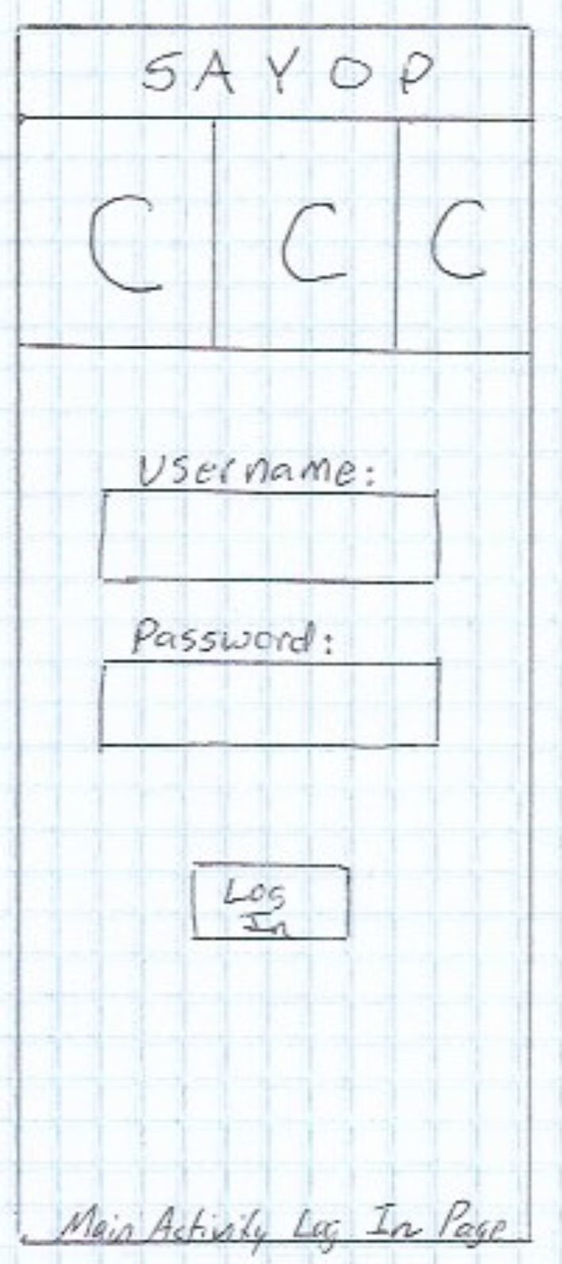 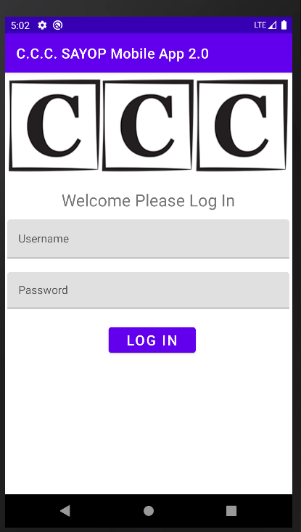

Figure 1: Low Fidelity

Figure 2: High Fidelity

Once a user logs in, they will be taken to the Main_Activity_Home_Page. The user can then select to view Terms, Courses, Assessments, or Reports.

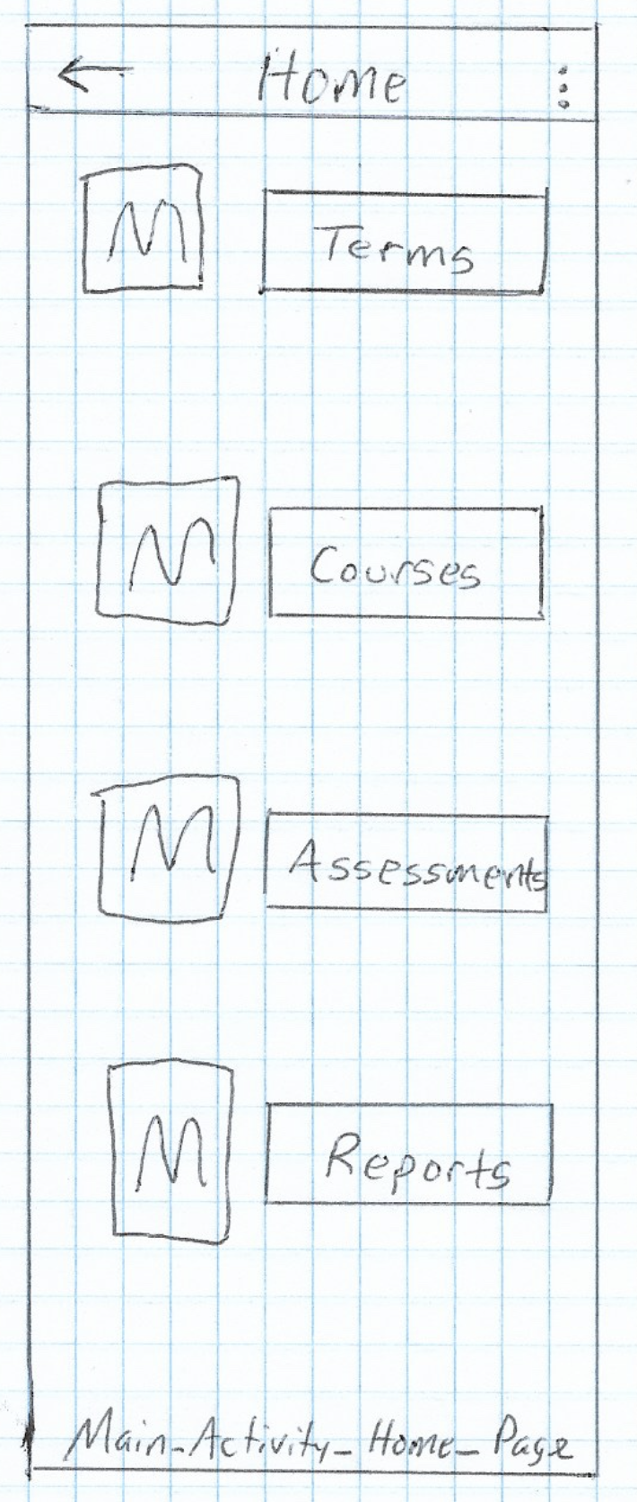 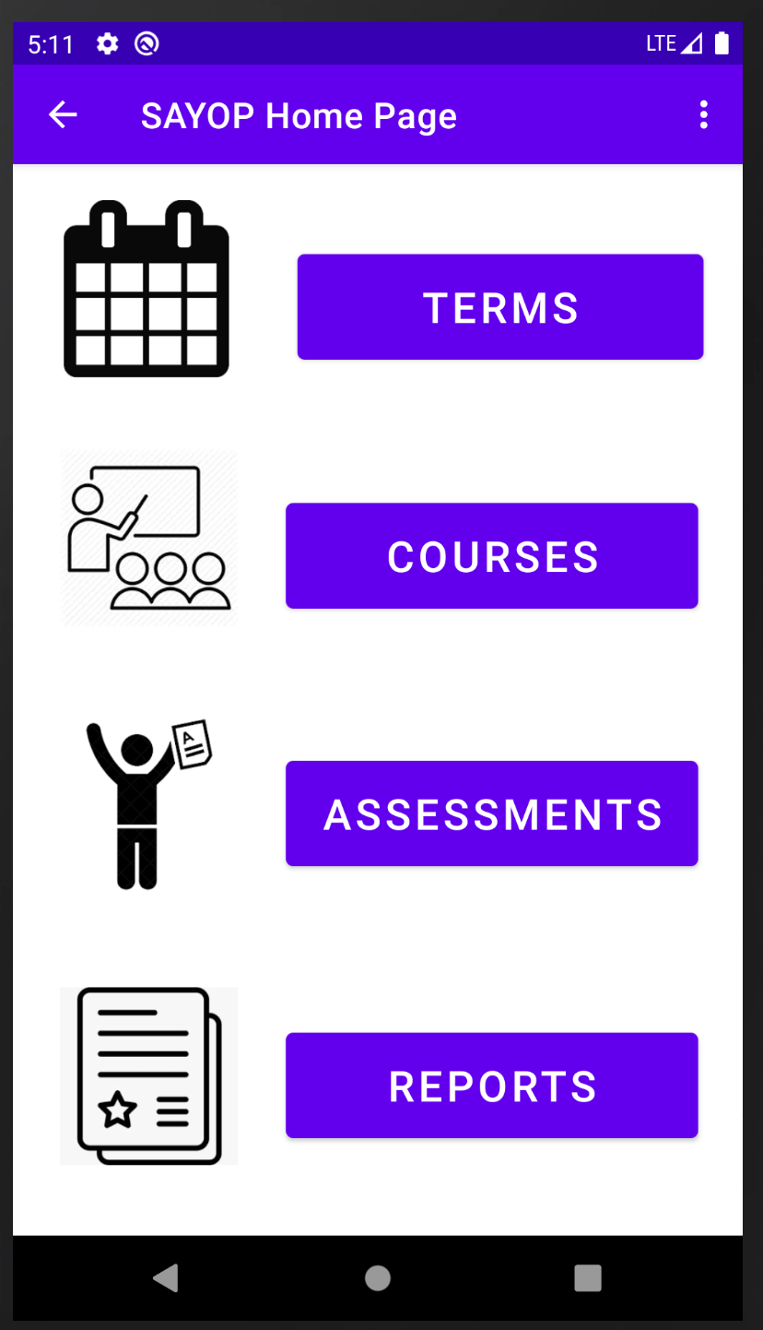

Figure 4: High Fidelity

Figure 3: Low Fidelity

Selecting the TERMS button will navigate to List_Terms. From this page the user will see all of the existing terms they are assigned to. The page will list the term name, the term start date, and the term end date. The user will be able to search the terms list, refresh the terms list, add a new term, edit a term, or return to Main_Activity_Home_Page.

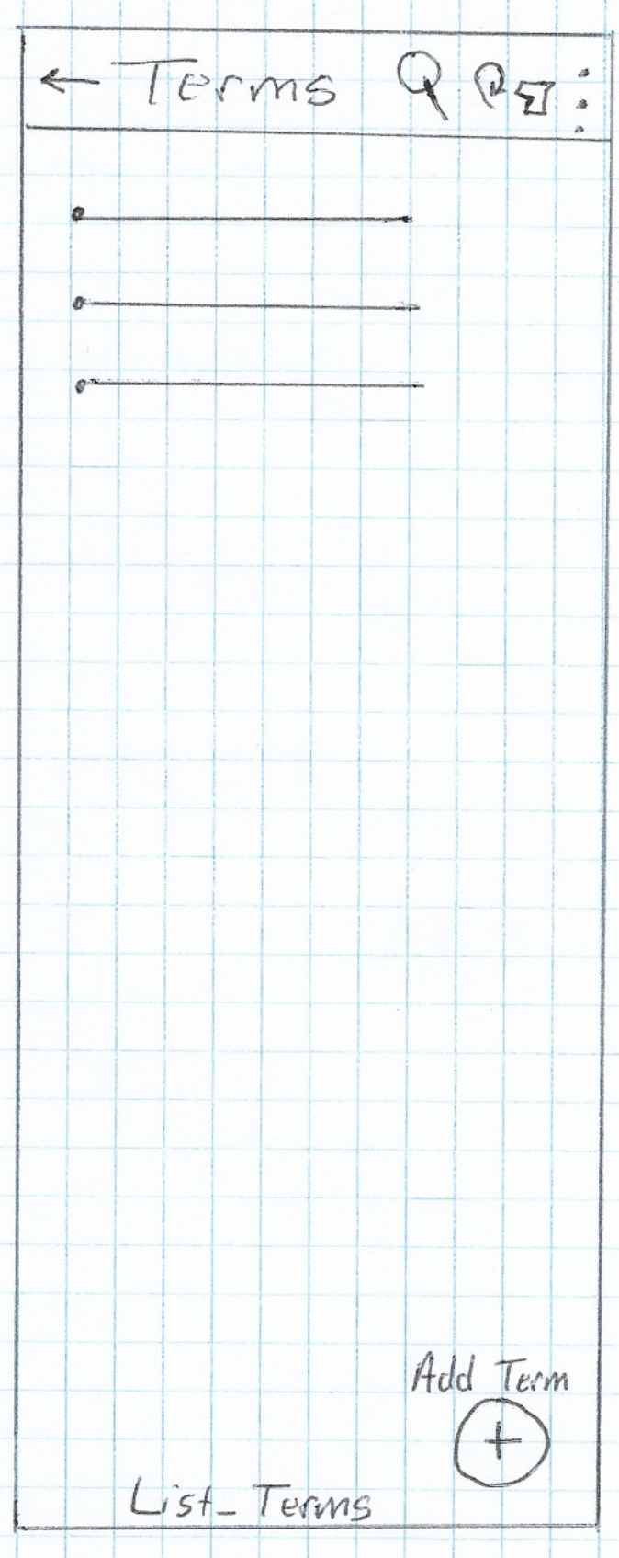 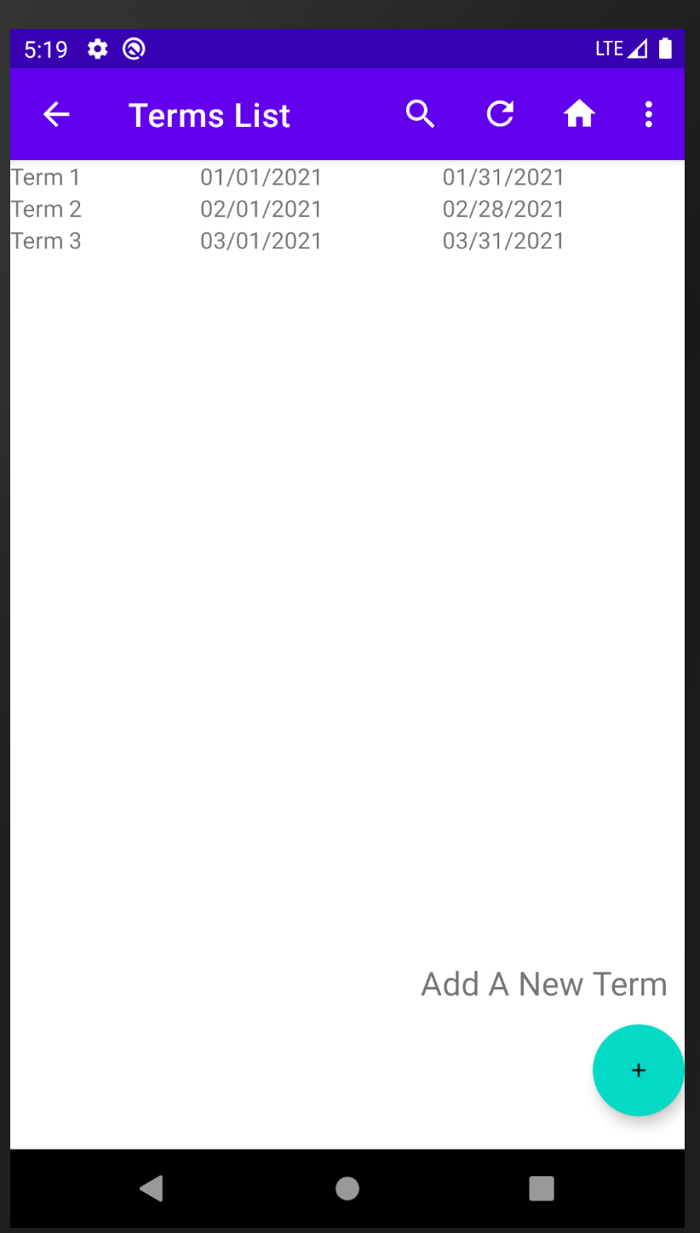

Figure 6: High Fidelity

Figure 5: Low Fidelity

Should the user decide to edit an existing term they will click on the term name in the list, and it will take them to Edit_Existing_Term. The user would be able to update the term name, start date, end date before saving. If the user wanted to add a new course or delete an associated course this would be done from the Edit_Existing_Term page. The user would also be able to send out a notification via SMS Text or Email about the Term. The user would also be able to delete the term provided no associated courses are showing. Or the user would be able to navigate back to Main_Activity_Home_Page.

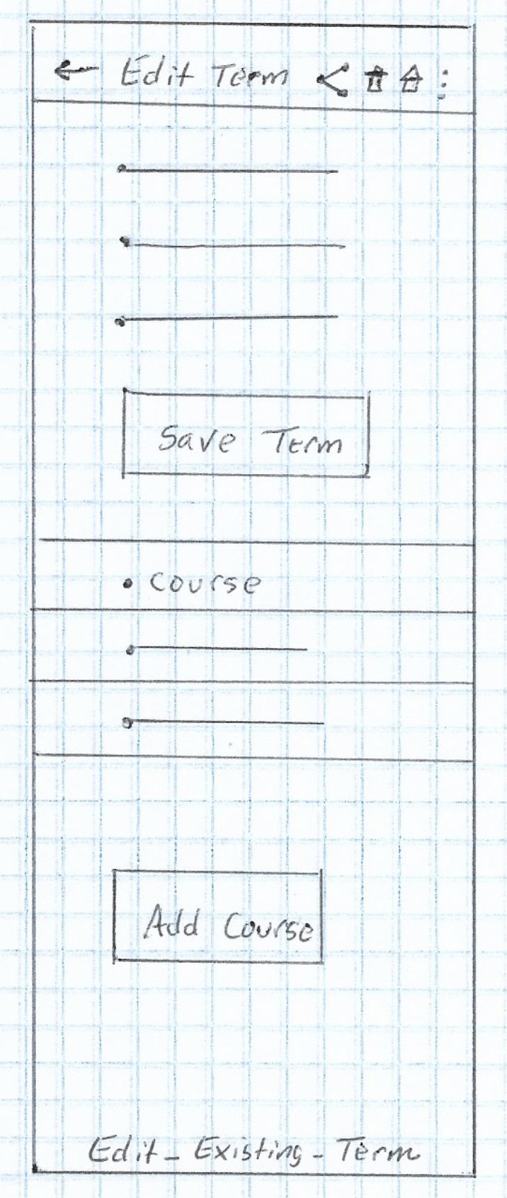 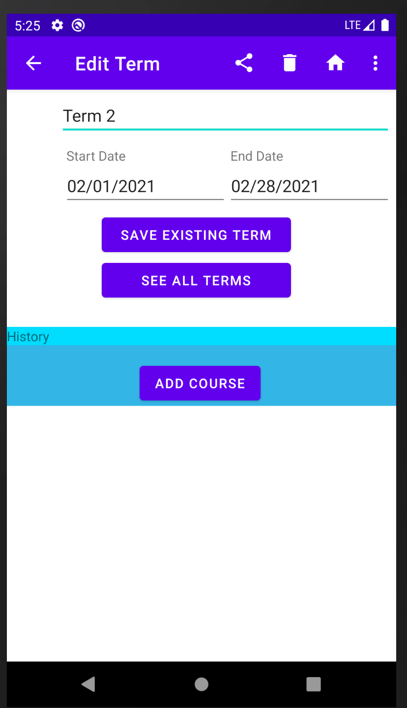

Figure 8: High Fidelity

Figure 7: Low Fidelity

If the user decided to add a new course to the existing term. They would click on the add course navigation button. The user would then be able to add a course name, start date, end date, status, instructor name, instructor phone, instructor email, and course note.

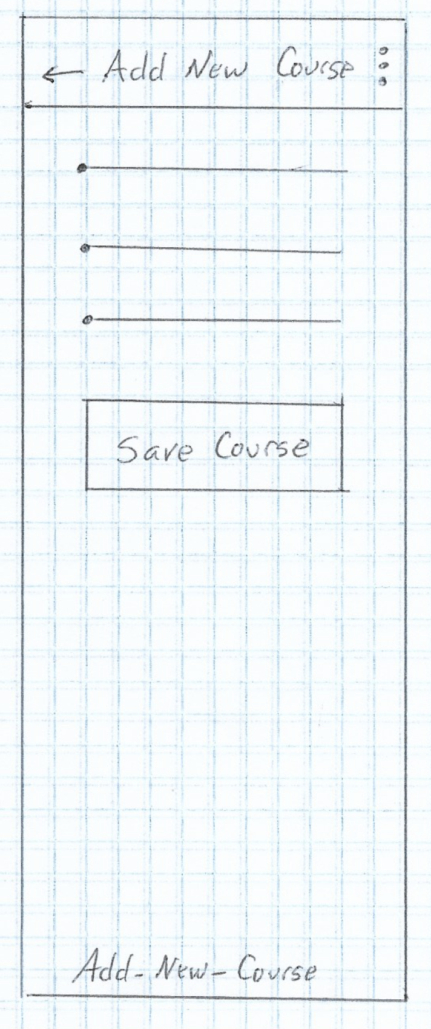 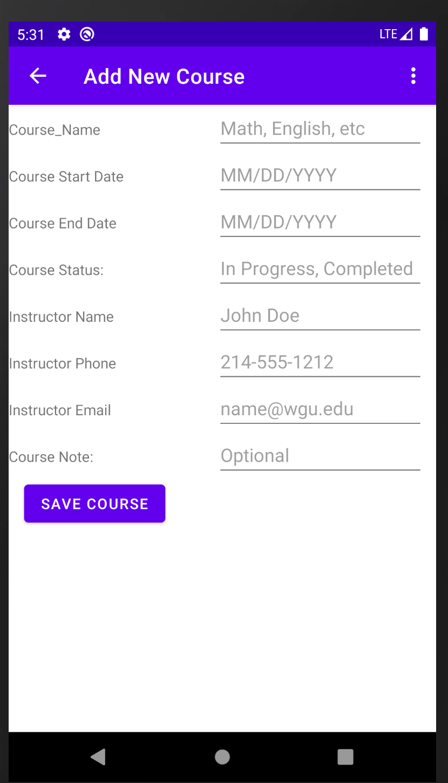

Figure 10: High Fidelity

Figure 9: Low Fidelity

From the List_Terms screen if the user decided to add a new term they would click on the floating action plus button to add a new term. This would take them to the Add_New_Term screen. The user would be able to add a term name, start, and end dates.

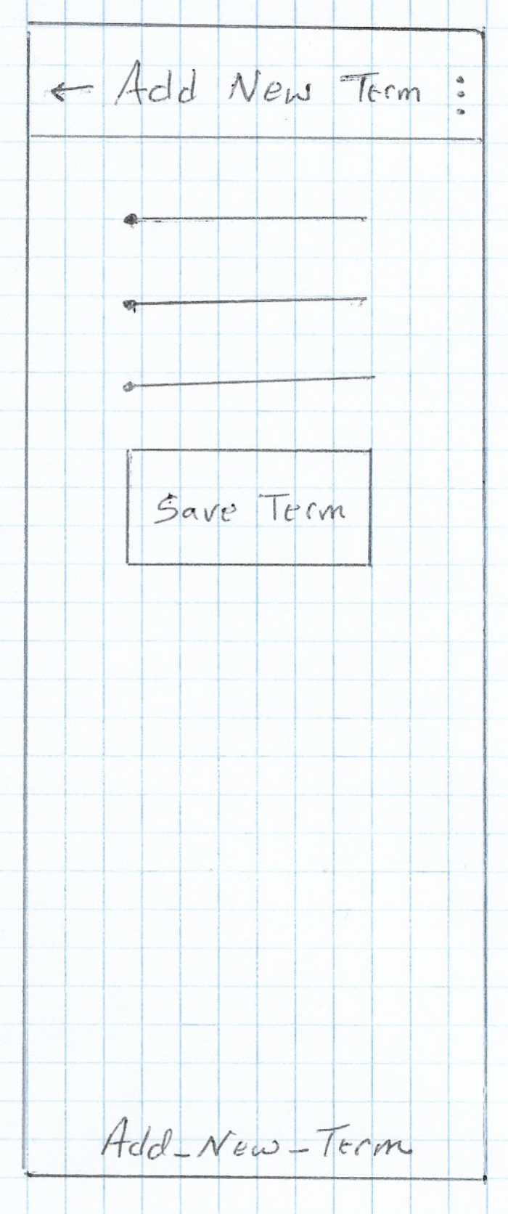 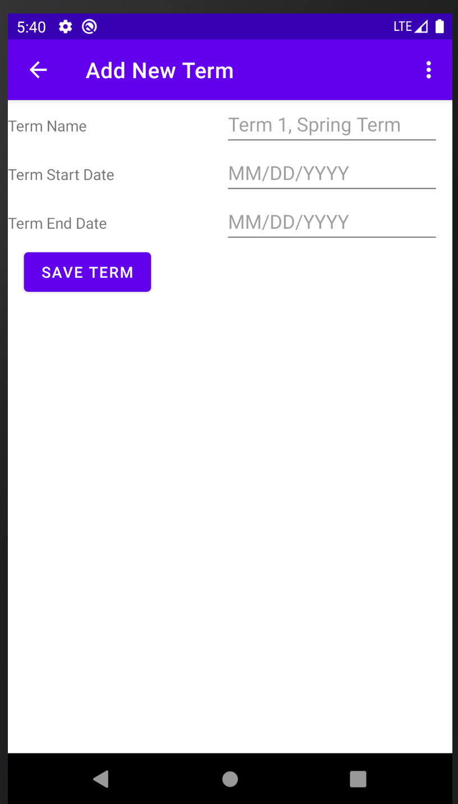

Figure 12: High Fidelity

Figure 11: Low Fidelity

From the Main_Activity_Home_Page if the user decided to view all courses, they are enrolled in they would click the Courses navigational button which would take them to List_Courses screen. From here they would be able to edit a course by clicking on the course name. From the menu they would be able to search through the course list by name. They would also be able to refresh the list or return to Activity_Main_Home_Page screen.

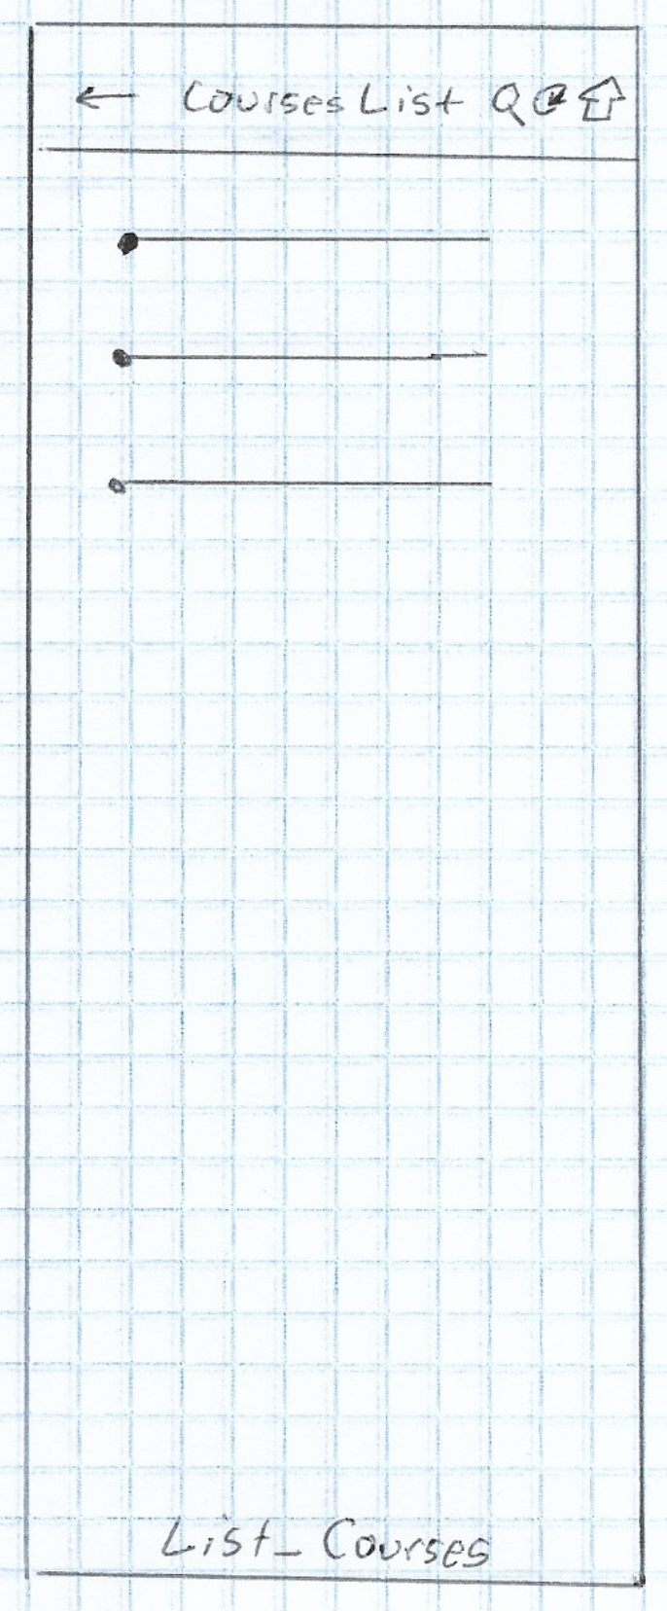 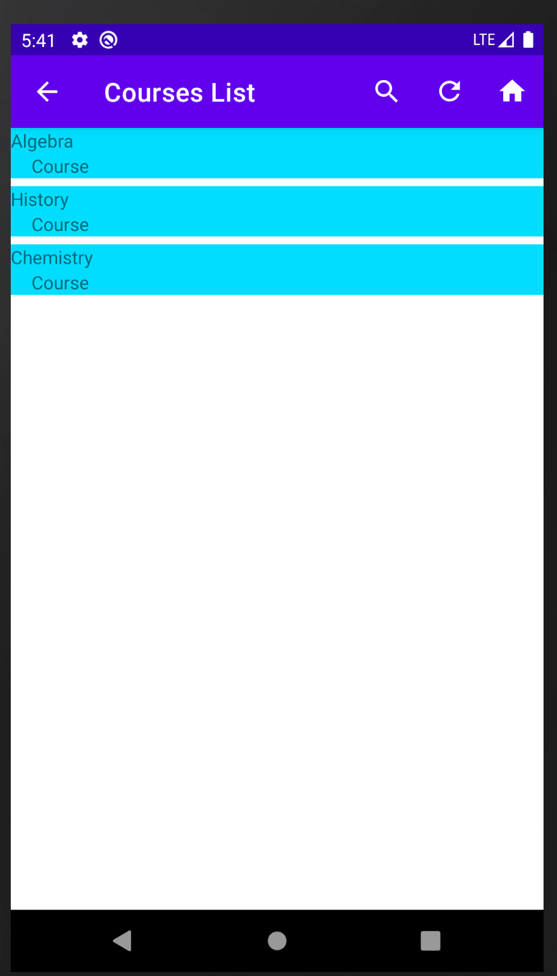

Figure 14: High Fidelity

Figure 13: Low Fidelity

From the Edit_Existing_Course page the user would be able to edit the course name, status, start date, end date, instructor name, instructor phone, instructor email, course note. The user would also be able to share the course details via SMS Text or Email. They would be able to delete the course provide no associated assessments are part of the course. The user would also be able to navigate to the home screen. They would be able to delete an associated assessment for that course in addition to adding a new assessment.

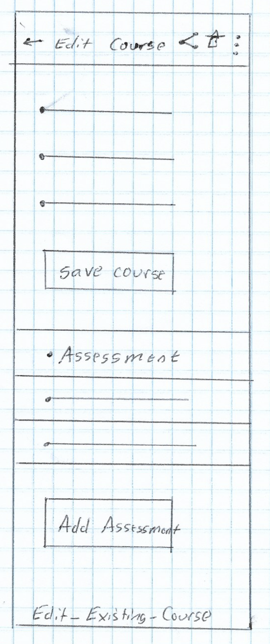 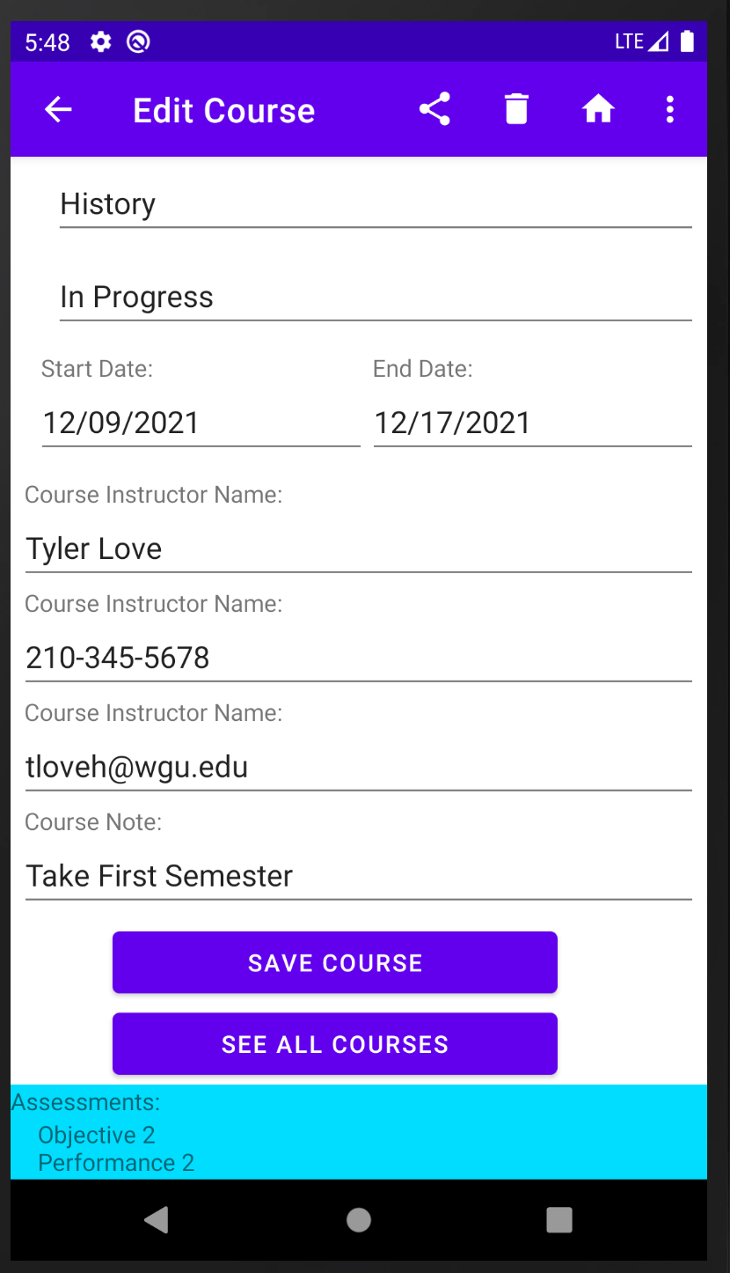

Figure 16: High Fidelity

Figure 15: Low Fidelity

From the Edit_Existing_Course if the user wanted to add a new assessment they would click the add new assessment navigational button and they would be taken to the Add_New_Assessment page. On this page the user would be able to add an assessment name, type, start date, and end date.

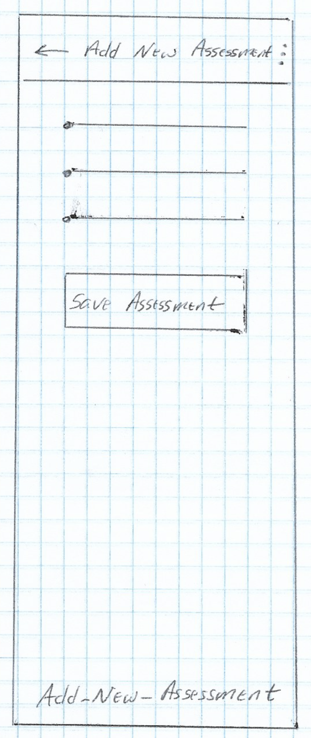 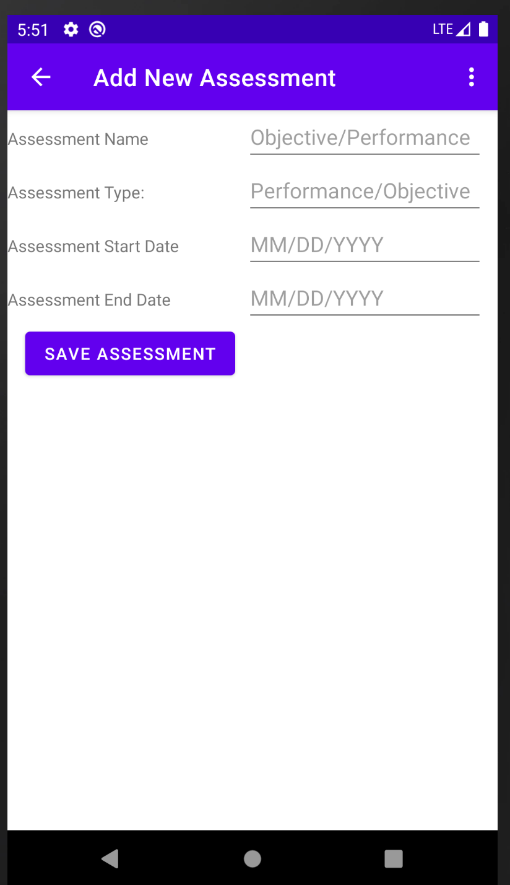

Figure 18: High Fidelity

Figure 17: Low Fidelity

From the Main_Activity_Home_Page if the user wanted to view all assessments, they are enrolled in they would click the Assessment navigational button and be taken to List_Assessments. From this screen the user would be able to edit an assessment, search through the list of assessments by name, refresh the assessments list, or return to Main_Activity_Home_Page.

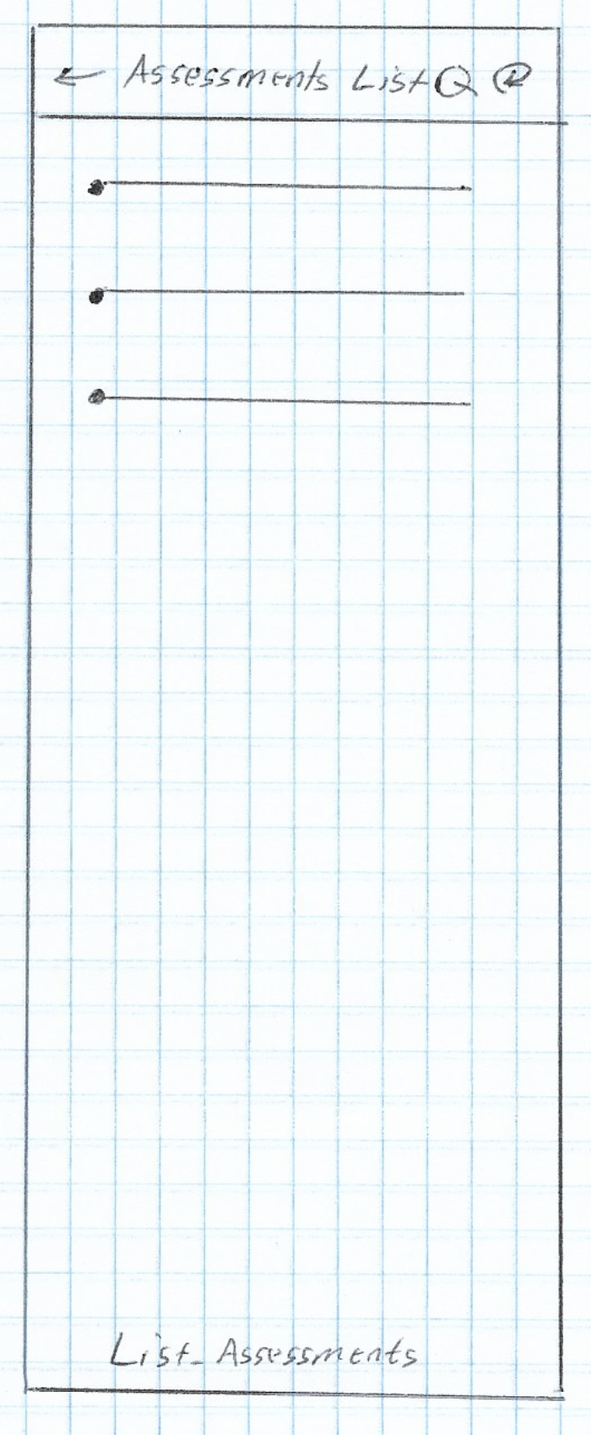 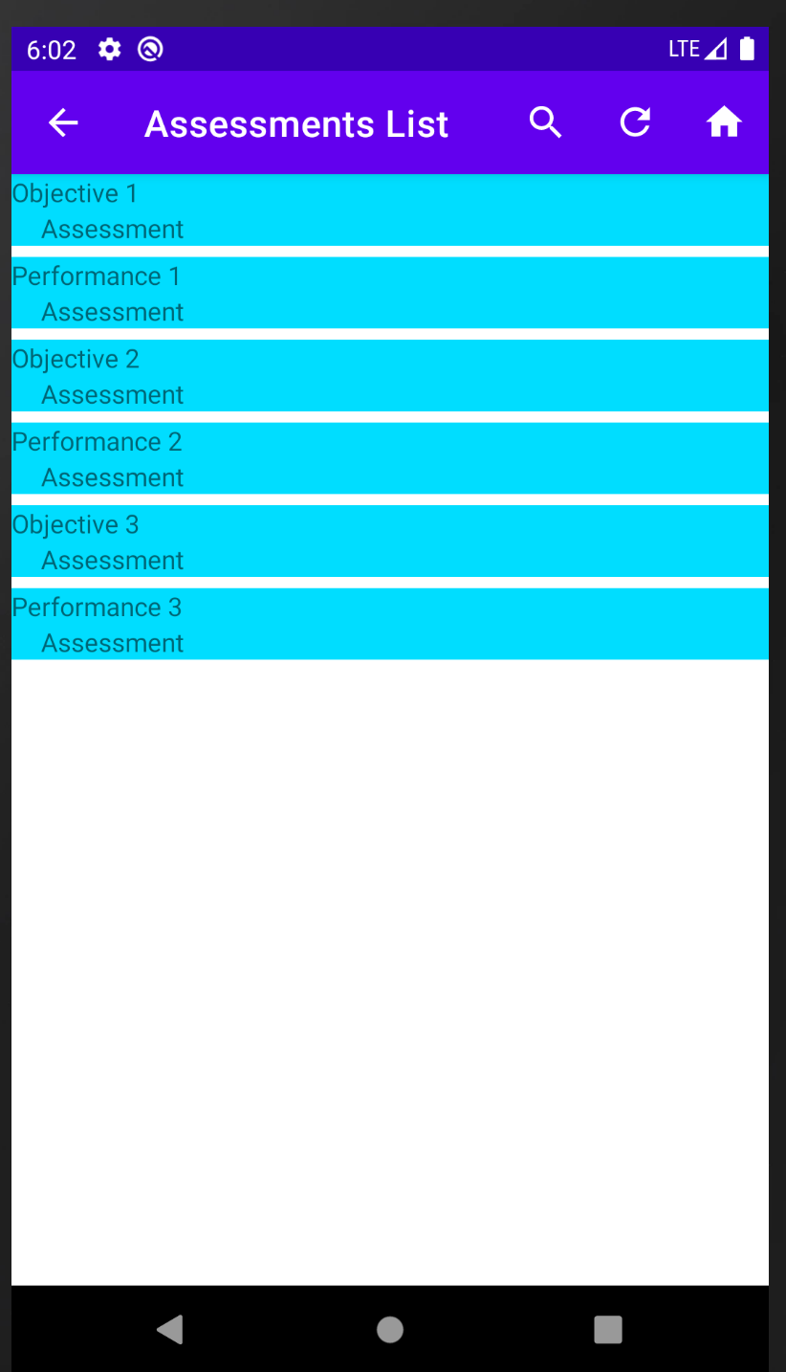

Figure 20: High Fidelity

Figure 19: Low Fidelity

If the user wanted to view edit an assessment, they would click on an assessment name from the list and be taken to Edit_Existing_Assessment. From here the user would be able to update the assessment name, type, start date, and end date. The user would also be able to share information about the assessment via SMS Text or Email. They would be able to delete the assessment or navigate to Main_Activity_Home_Page.

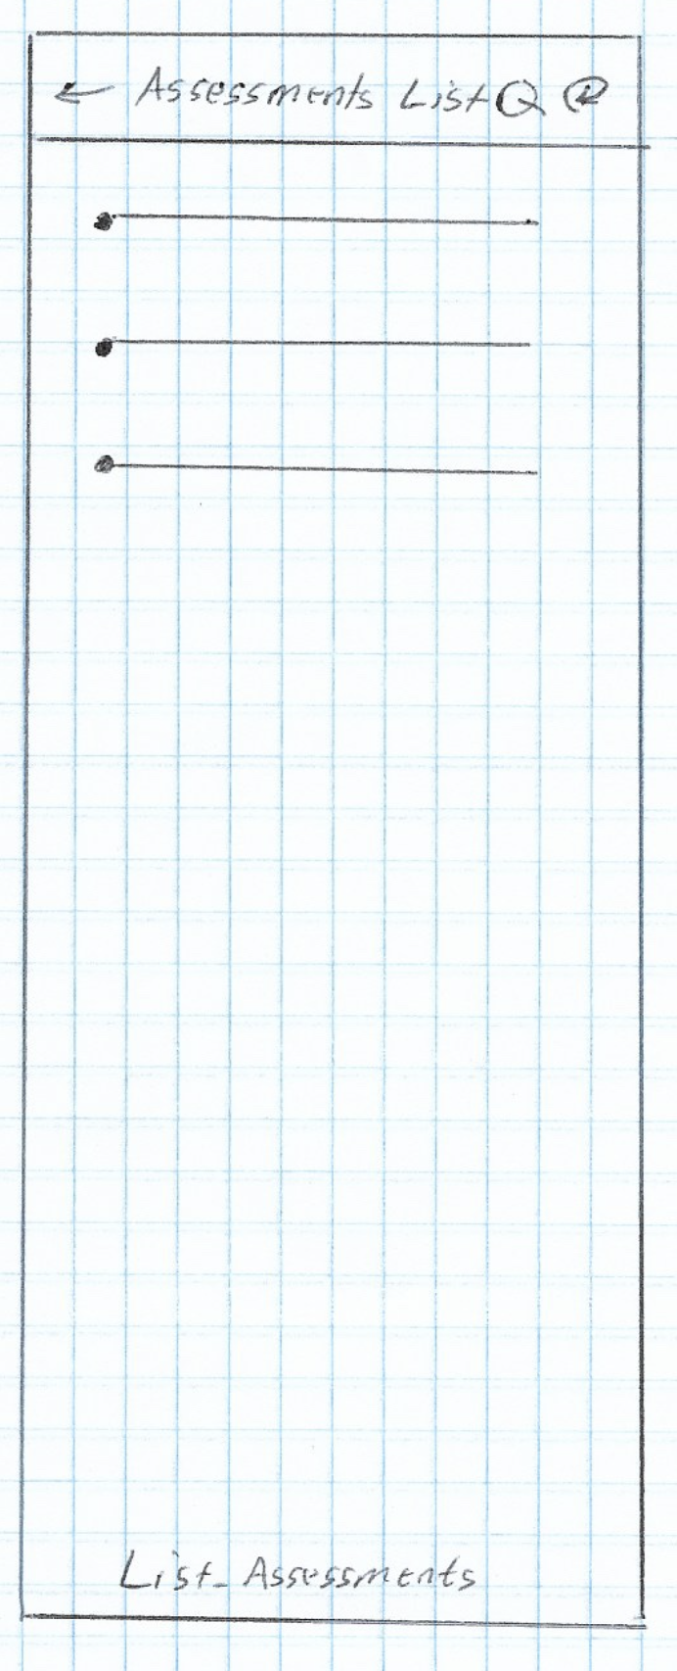 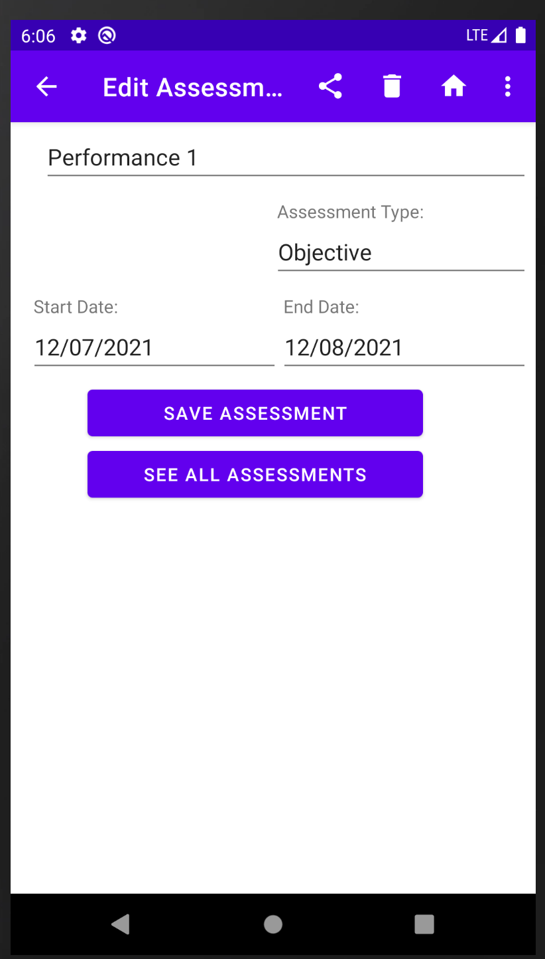

Figure 22: High Fidelity

Figure 21: Low Fidelity

From the Main_Activity_Home_Page if the user wanted to generate different types of reports, such as Terms List, Courses List, Assessments List, or Instructors List they would click on the Reports navigation button which would navigate to Reports_Page.

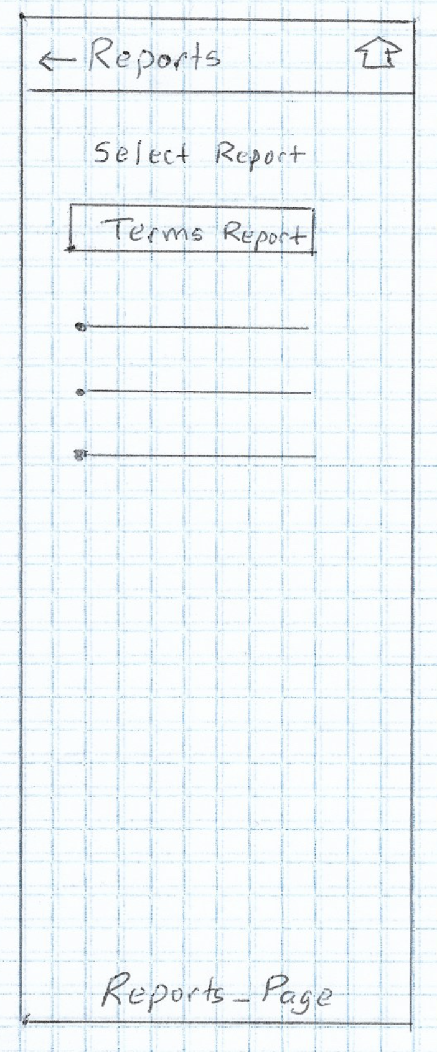 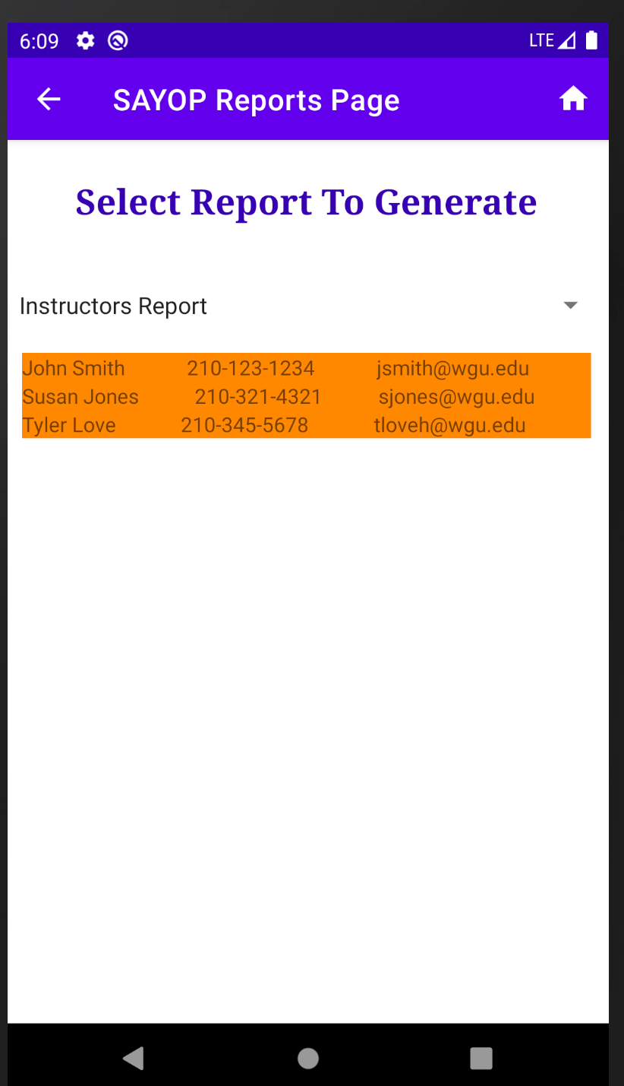

Figure 24: High Fidelity

Figure 23: Low Fidelity

# Unit Test Plan

## Introduction

### Purpose

Provide a brief description of the testing method(s) that you used and what the results it yielded. Also, what remediation was required if necessary and how it would be performed.

### Overview

Here you go into more detail about the test(s) and how it related to the overall project. You should include if a similar method was used in other parts of the application or why this was unique for a certain aspect of the code. Then, go into detail about what functions were tested, how the tests were conducted, and how errors were dealt with.

## Test Plan

### Items

What is required to complete the test(s)?

### Features

List the function/features that are part of each test.

### Deliverables

List what the test(s) would produce. For example, documentation or code notations.

### Tasks

List the tasks required to complete the testing and provide the outcomes you identified.

### Needs

Describe what was needed to be running or what support items had to be in place to perform the test? Specify versions if appropriate and other technical requirements. If a testing package and/or library was employed, be sure to identify it/them.

### Pass/Fail Criteria

Describe the criteria you used to determine the success of the test and what the protocol was for a positive result. Also describe what the recourse was if the test failed including remediation strategies and documentation requirements.

## Specifications

Provide sample code that represents what testing code was used. Screenshots are acceptable.

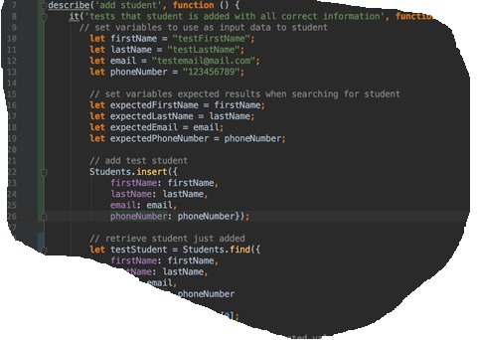

## Procedures

Provide a detailed list of the steps you used to complete the testing process. Be sure to mention if iterations were/are part of the process used and when pass/fail results were provided.

## Results

Here you will describe and provide examples of the testing results. If you were using a testing package include a screenshot of the interface. Screenshot work best.

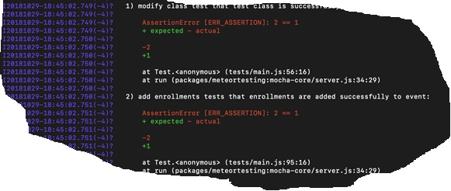

# C4. Source Code

All source code for the application must be submitted with your documentation. Remember, this must be a fully functional application and the evaluator will need the code and other functional pieces to make the application launch and work as described. For web-based applications, a live website is advantageous and must be accessible to the evaluator, but you still must submit the complete code. Use a separate file for this section and identify the name.

# C5. Link to Live Version

Again, is a live version of the app can be viewed, provide the link or location where it may be found. Include a username and password if applicable.

# User Guide

*Note: This may be included as a separate document if you desire.*

## Introduction

Provide a description of the content you’re providing in the User Guide. This guide will include how to install, log into, sign up, and use all of the functions of the application. The steps need to be clearly defined and fully tested so the process works flawlessly for the evaluator.

## Installation and Using the Application

This procedural information should follow the basic rules of such technical references. While some procedures may provide for personal judgment yours should be clear and concise. Here are other rules to remember:

* Provide step-by-step sequences in the correct order.
* Follow the timing and sequencing of the actual operations.
* Provide visual stepping stones by using bullets or labeling steps.
* Strive to be concise. Avoid lengthy paragraphs but include enough detail so false assumptions are not made.
* Use common terms and jargon appropriate for the audience (someone with basic IT background).
* Explain why steps are completed or what they will yield as well as "How to" instructions.
* Test the instructions to ensure they match the actual product.
* Format the material for ease of reading and use graphic aids to clarify point/steps.
* Write in the present tense and the active voice.

## *Login and Signup (An example*)

1. *Click the "Log in" button in the top right corner of the app.*

**

1. *If you already have an account, log in with your account name and password. If you need an account, click on the link below that states “Need an account?”*
2. *If you need to create an account, choose a unique username and password. By default, the password requires at least 6 characters. This function could be changed to address new password requirements.*

## *Classes*

### *Create a New Class*

1. *Once logged in, click on the link at the top labeled “Classes”. This will enable you to create a new class of students.*

**

1. *Click on “+ Add Class”.*

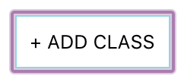

1. *Enter a class name and its description. The class name must be unique.*
2. *Click “Add Class” to add the class, otherwise click “Cancel” or outside of the modal to cancel adding the class.*

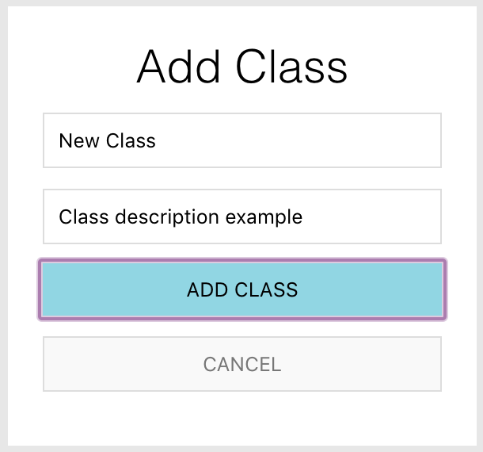

## *Reports*

1. *To access the reporting feature, from the Schedule module, click on “Generate Report” near the top right of the page.*

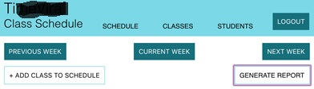

1. 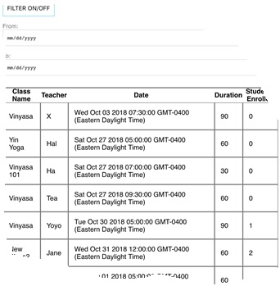*By default, all events are generated and displayed.*